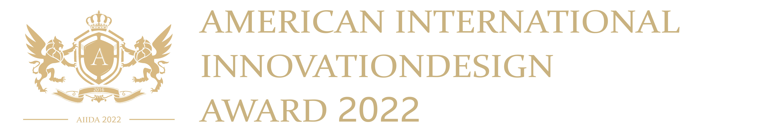

Agency information
Company
Website |  | E-mail
Address
Contacts |  |  | Contacts’ e-mail
Company profile
Project information
Project name
Categories | Interior design □ Architecture and Landscape design □ Product design □
Interior design | Hotel space□ Restaurant & Bars □ Cultural space □ Official space □  Villa space□ Entertainment space □ B&B hotel space □  Lighting design □ Commercial space□ Exhibitions □  Real estate and sales space □ Showroom □ Residential space □  Home decoration □ Other:
Architecture and Landscape design | Hospitality □ Cultural buildings □ Commercial buildings □  Office □ Museum □ Sports buildings □  Transportation□ Real estate sales buildings□ Residential buildings□  Villa □ B&B Hotel □ Healthcare □ Urban planning□  Scenic area planning□ Theme Park□ Other:
Product design | Home Appliances □ Lamp □ Accessories □  Digital & Electronic Devices □ New Materials □  Smart Home □ Kitchen Accessories □ Bathroom Fittings □  Cultural and Creative Products □ Other:
Project description

